**Lab 1 Cloud Infrastructure Management Date: 05-01-2024**

**CARRY OUT AN EXPERIMENT TO CREATE AND DEMONSTRATE THE WORKING STATIC WEB SERVER.**

1.Install apache2 and check the status with below commands

* sudo apt update
* sudo apt install apache2
* sudo ufw app list
* sudo ufw allow 'Apache'
* sudo systemctl status apache2

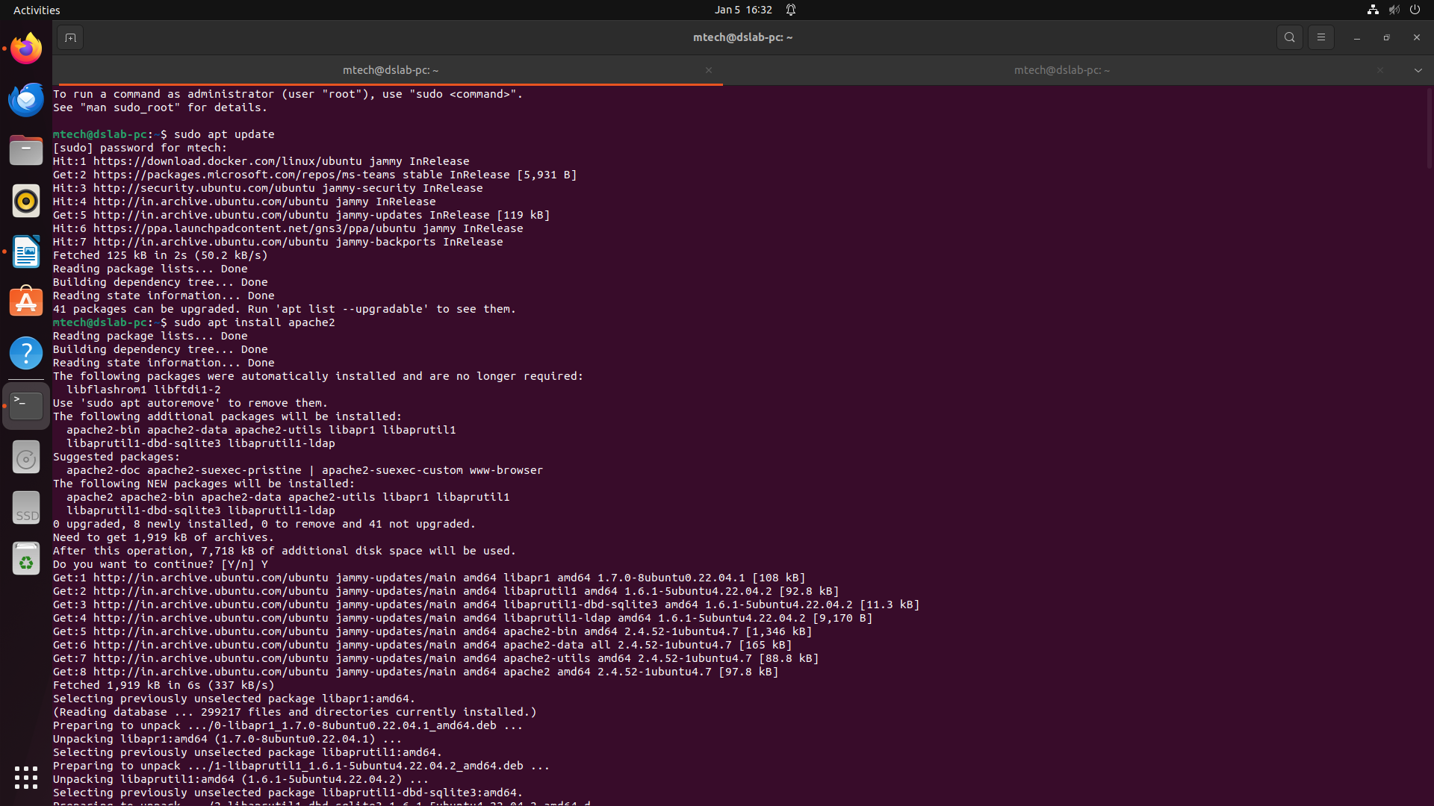

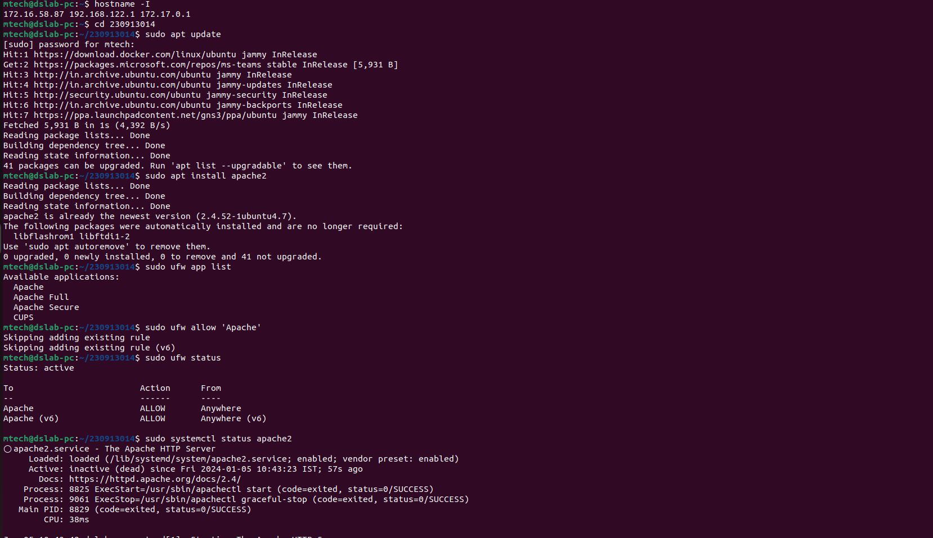

2.To obtain system IP type below command

• hostname -I



3.Start the apache server. Open chrome tab and enter the system ip. Default page will load

4.To start reload and stop use below commands

• sudo systemctl stop apache2

• sudo systemctl start apache2

• sudo systemctl restart apache2

• sudo systemctl reload apache2

5.To create new static page create new folder with domain name

• sudo mkdir /var/www/172.25.187.85

6.Create index.html in the newly created folder

sudo nano /var/www/172.25.187.85/index.html

<html>

<head>

<title>Welcome to your_domain!</title>

</head>

<body>

<h1>Success! The your_domain virtual host is working!</h1>

</body>

</html>

7. Create new configuration file

sudo nano /etc/apache2/sites-available/172.25.187.85.conf

<VirtualHost *:80>

ServerAdmin webmaster@localhost

ServerName 172.25.187.85

ServerAlias www. 172.25.187.85

DocumentRoot /var/www/172.25.187.85

ErrorLog ${APACHE_LOG_DIR}/error.log

CustomLog ${APACHE_LOG_DIR}/access.log combined

</VirtualHost>

8.Disable default conf

• sudo a2dissite 000-default.conf

9.Enable 172.25.187.85.conf

• sudo a2ensite 172.25.187.85.conf

• sudo apache2ctl configtest

10.Restart apache

• sudo systemctl restart apache2

